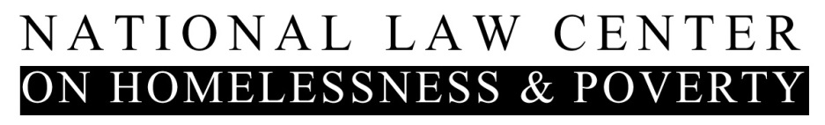

**Key Accomplishments: 2016**

In 2016, the National Law Center on Homelessness & Poverty advanced an ambitious agenda to prevent and end homelessness—and to protect the human dignity and rights of people without housing. Your generosity and support made major victories and initiatives possible, including:

**Impact litigation protecting basic rights and dignity:**

* Wisconsin’s Voter ID Law is being challenged in court by the Law Center and the ACLU in the *Frank v. Walker* case. A federal trial ruled that people experiencing homelessness can still vote even when they have trouble obtaining identification.
* The Law Center worked with pro bono partner Baker Donelson LLP and others filing an Amicus Brief in *Citizens for Strong Schools vs. Florida State Board of Education,* charging that Florida failed to meet the constitution's standards for a public education.
* We advocated for people living in encampments by providing assistance in *Cobine v. City of Eureka* (CA) and *Buker v. City of Akron* (OH), helping plaintiffs win a court order requiring Akron to provide due process to homeless citizens in encampments.

**Our strategic advocacy won new support and rights:**

As a result of the Law Center’s federal advocacy:

* A bipartisan coalition in Congress passed the Federal Assets Sale and Transfer Act of 2016 (FAST Act), creating housing by using surplus federal property.
* The White House, with the Law Center as a key partner, launched the Data-Driven Justice Initiative to reduce the criminalization of homelessness.
* The U.S. Department of Justice (DOJ) released a *Comment Letter on Seattle Council’s Bill 118794*, limiting the removal of people and their property from public spaces, based on the brief it filed in our case, *Bell v. Boise,* with our influence.
* The U.S. Department of Housing and Urban Development (HUD) released key guidance for the Fair Housing Act, declaring policies that ban everyone with a criminal record from housing, are illegal.
* HUD increased the points on its funding application to communities ending the criminalization of homelessness, and issued guidance and regulations protecting the housing rights of domestic abuse victims.
* The Law Center helped strengthen the U.S. Department of Education’s *Every Student Succeeds Act Homeless Children and Youth Guidance,* including providing guidance on criminalization, a barrier to education, adequate and appropriate transportation.

At the state and local level:

* The Law Center played a critical role in helping Indianapolis become the first city in the country to enact a law requiring local government to provide adequate housing before evicting people from encampments.
* We helped write Delaware’s Homeless Bill of Rights, which is currently pending.

**Conducting record outreach, helping thousands of providers, advocates, and communities:**

* We produced manuals and reports - including Our *Housing Not Handcuffs* Report showing the criminalization of homeless has been on the rise. Our materials were downloaded 87,697 times in 2016.
* We held webinars educating advocates, lawyers, and organizers across the country in 47 states and the District of Columbia.
* With our legal advocacy network, Project LEARN, we protected the rights of homeless children and youth, positively affecting millions.
* Our National Forum on the Human Right to Housing convened and educated over 100 key leaders - attorneys, advocates, government representatives, funders, and formerly homeless individuals.
* We initiated the *Housing Not Handcuffs* Campaign together with more than 100 organizations, with a goal of moving law and policy away from criminalization and towards housing. We reached millions of people with our media outreach and coverage, shining a light on the needs of homeless Americans and supporting our work to shift policies and change systems, including coverage and in the *New York Times*, *Washington Post*, *Huffington Post*, *NPR*, and *The Atlantic*.





Maria Foscarinis, the executive director of the *National Law Center on Homelessness & Poverty*, said…“such lawsuits have been bolstered by the U.S. Justice Department's decision to file a brief opposing punishing homeless people for violating public camping bans when there is no room in shelters, in a lawsuit challenging Boise, Idaho's enforcement of its ban, a case her organization is involved in.”



“A[recent National Law Center on Homelessness & Poverty report](https://www.nlchp.org/documents/No_Safe_Place) found a noticeable increase (in the criminalization of homelessness), with 24 percent of cities banning it altogether and 76 percent banning it in particular areas.”





"These laws are unconstitutional and bad public policy," Maria Foscarinis, the center's executive director, said in a phone call with reporters. "Homelessness remains a national crisis across the country. It's fueled by the growing lack of affordable housing and the shrinking safety net."